Email Templates

Subject: Introducing QRemember Memorials – Cherishing Memories Forever

Dear [Client Family’s Name],

At [Funeral Home’s Name], we understand the deep importance of cherishing and preserving the memories of your loved ones. That is why we are thrilled to
introduce our new offering: QRemember Memorials.

QRemember Memorials comprises a beautiful QR plaque and qr Memorial
application. The QR plaque can be displayed in a location of your choice, while the qr Memorial application serves as a digital space, providing easy access to your
loved one’s legacy. It allows you to store, share, and revisit cherished memories anytime, anywhere.

Our team is dedicated to helping you create a meaningful tribute that transcends time. The QRemember Memorials offering aligns perfectly with our commitment to providing exceptional service and honoring the lives of those dear to you.

We invite you to schedule a consultation with our team to learn more about how we can beautifully encapsulate your loved one’s story and provide a legacy.
We are here to guide you every step of the way and ensure that your memories endure for generations to come.

Please feel free to reach out to our dedicated staff at [Funeral Home’s Phone
Number] or [Funeral Home’s Email Address] to arrange a time that suits you.
We look forward to the opportunity to share more about the benefits and possibilities that we offer.

With deepest sympathy and warm regards,

2023 QRemember, LLC. All Right Reserved.

Email Templates

Subject: Preserving Memories for Generations - Introducing QRemember Memorials

Dear [Client Family’s Name],

We hope this message finds you well during this time of remembrance. At [Funeral Home’s Name], we are constantly seeking ways to honor and preserve the precious memories of your loved ones. That’s why we are thrilled to introduce our latest
offering: QRemember Memorials.

QRemember Memorials combines a beautifully crafted QR plaque with our
innovative qr Memorial application, empowering you to eternalize and share your
loved one’s legacy in a truly unique way. The QR plaque can be displayed wherever you choose, while the qr Memorial application serves as a digital sanctuary,
allowing you to store, share, and revisit cherished memories at any moment.

We understand the importance of creating a lasting tribute that resonates with
your family’s values. QRemember Memorials reflects our commitment to providing exceptional service and ensuring that your loved one’s memory remains alive for generations to come.

We invite you to connect with our compassionate team for a personal consultation, where we can further discuss the benefits and possibilities that QRemember
Memorials offer. Reach out to us at [Funeral Home's Phone Number] or [Funeral Home’s Email Address] to schedule a convenient time.

We are honored to assist you in preserving and celebrating the legacy of your
loved one. Let QRemember Memorials be a beacon of remembrance, ensuring that their memory shines brightly for all time.

With heartfelt compassion,

2023 QRemember, LLC. All Right Reserved.

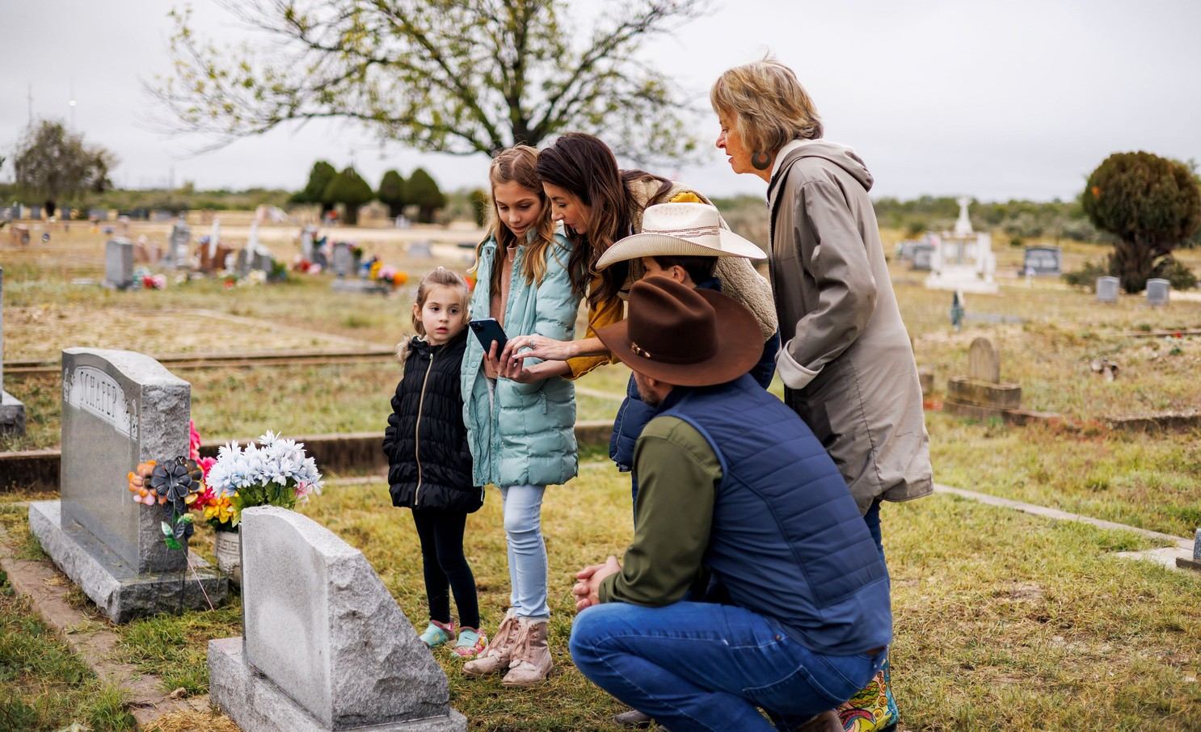Email Templates
2023 QRemember, LLC. All Right Reserved.

Subject: Honoring Memories: Discover QRemember Memorials for Lasting Legacies

Dear [Client Family’s Name],

We are excited to introduce QRemember Memorials, a powerful way to preserve and share the cherished memories of your loved one. With a beautiful QR plaque and our qr Memorial application, you can eternalize their legacy and easily store, share, and revisit memories anytime.

Discover how QRemember Memorials can create a lasting tribute. Contact us at
[Funeral Home’s Phone Number] or [Funeral Home’s Email Address] to learn more and schedule a consultation.

Preserve their memory, forever.

Warm regards,

Email Templates
2023 QRemember, LLC. All Right Reserved.

Subject: Introducing QRemember Memorials - Embrace a Digital Legacy

Dear [Client Family’s Name],

Embrace the power of a digital legacy with QRemember Memorials. We are thrilled to introduce our innovative offering that allows you to preserve and share the
treasured memories of your loved one in a meaningful and enduring way.

Capture their essence with our QR plaque and qr Memorial application, seamlessly storing, sharing, and revisiting memories at your fingertips. Discover how
QRemember Memorials can create a lasting tribute and keep their memory alive.

To learn more and embark on this transformative journey, contact us at [Funeral Home’s Phone Number] or [Funeral Home’s Email Address] to schedule a
consultation.

Unleash their digital legacy today.

Warm regards,

